5.0

2.5

0.0

0.00

−0.04

b_Intercept

−0.08

−0.12

b_temp_scaled

0.2

0.1

sd_Species Intercept

0.0

0 2000 4000 6000 0 2000 4000 6000 0 2000 4000 6000

sd_Species temp_scaled

cor_Species Intercept temp_scaled

0.15

0.10

0.05

0.00

1.50

1.25

1.00

1.0

0.5

sd_species_tree Intercept

0.0

−0.5

−1.0

### Chain

1

2

3

4

0 2000 4000 6000 0 2000 4000 6000 0 2000 4000 6000

0.20 5.0

sigma

Intercept

0.19

2.5

0.18

0.0

0 2000 4000 6000 0 2000 4000 6000

## **B** PP Check − lmat model out

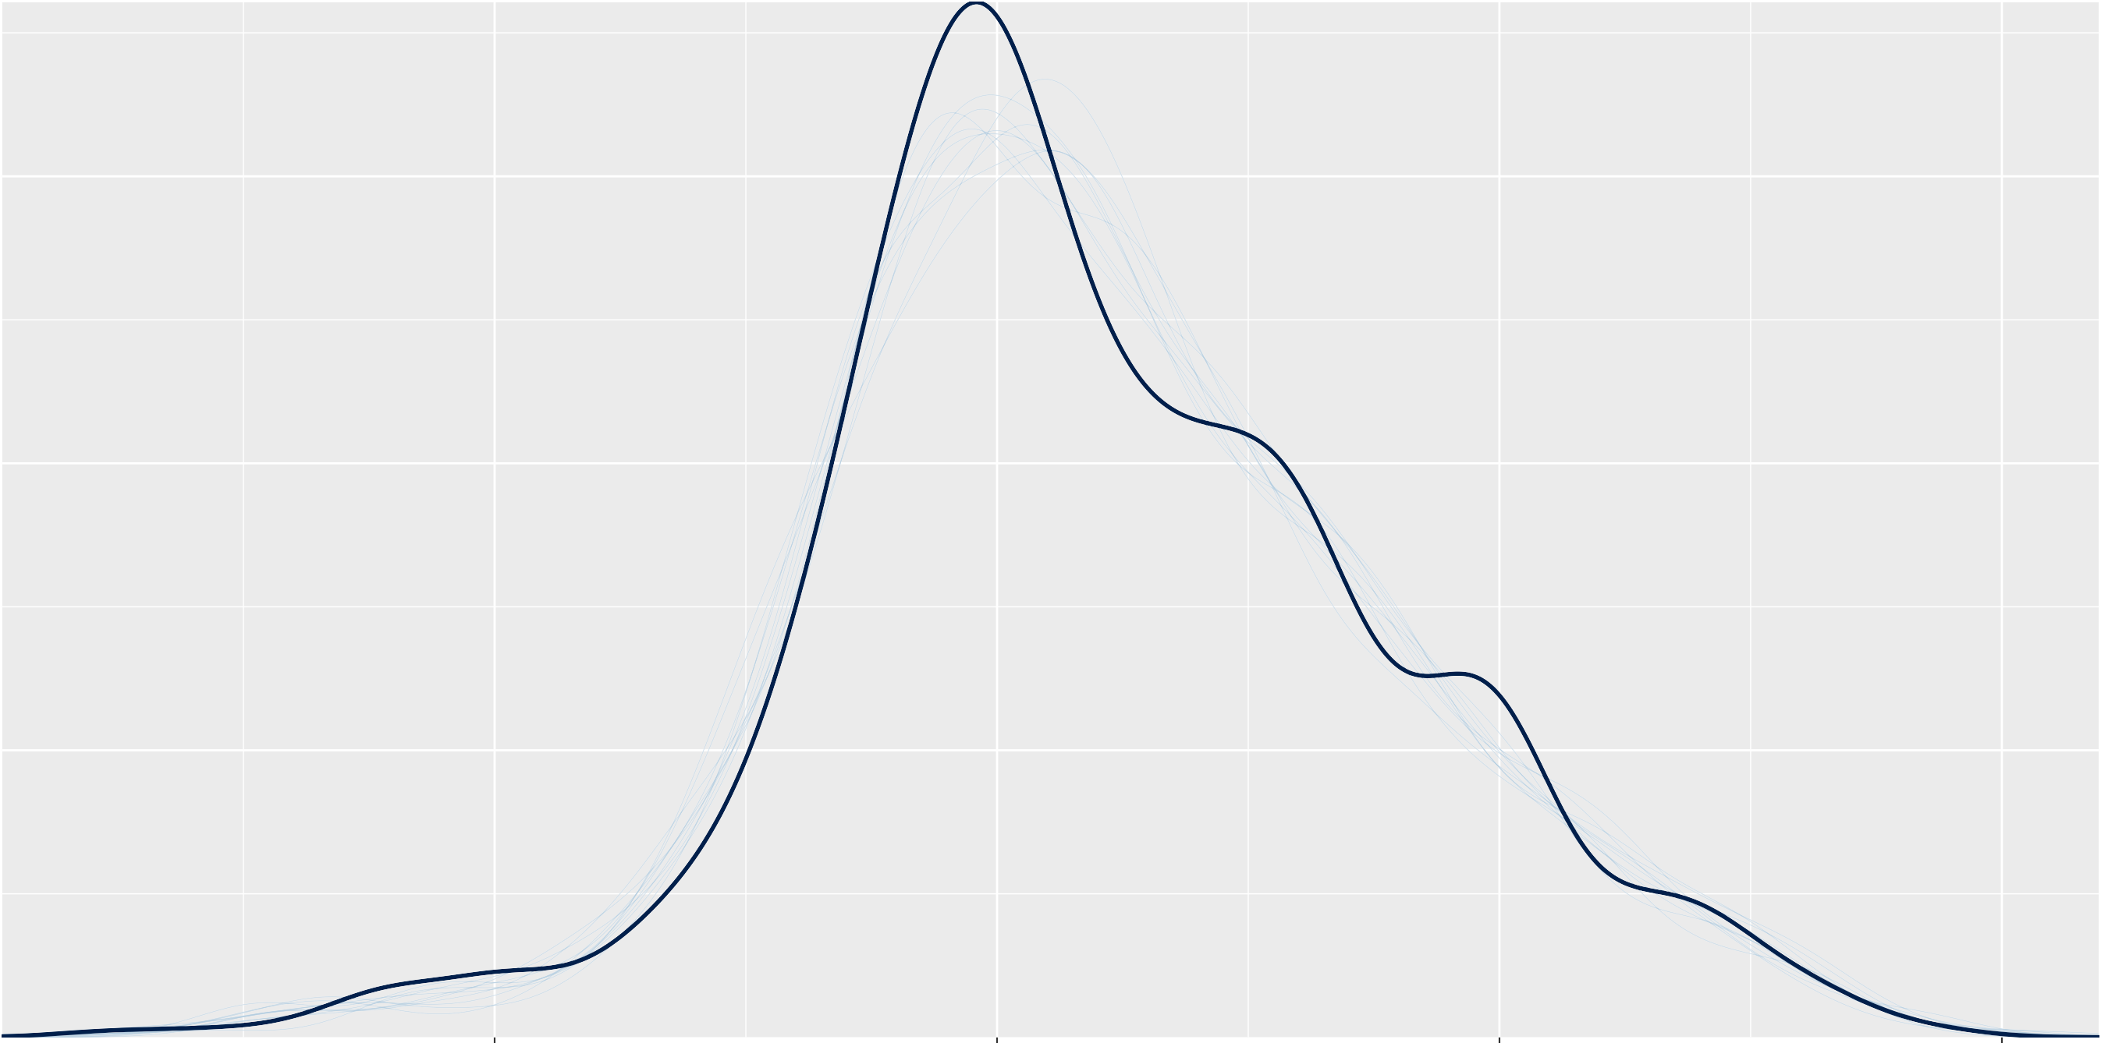*y*

*y*rep

3 1.00

b_Intercept

sd_Species Intercept

sd_species_tree Intercept

3

2 0.75

1 2

0.50

0

1

−1 0.25

−2 0.00 0

0 2000 4000 6000 0 2000 4000 6000 0 2000 4000 6000

r_Species[Acanthopagrus.bifasciatus,Intercept]

3

phi

40

2

30 1

0

20

−1

10

−2

1

0

Intercept

−1

### Chain

1

2

3

4

0 2000 4000 6000 0 2000 4000 6000 0 2000 4000 6000

1

r_Species[Bodianus.frenchii,Intercept]

r_Species[Calotomus.carolinus,Intercept]

1

0 0

−1 −1

−2

0 2000 4000 6000 0 2000 4000 6000

## **B** PP Check − sex phy model noprotog

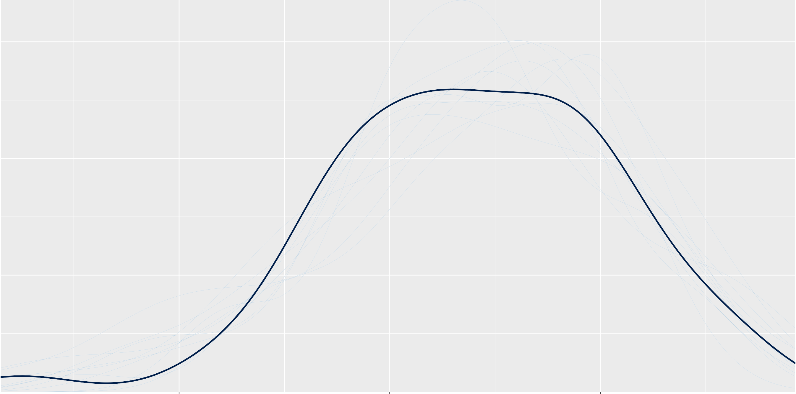*y*

*y*rep

−2.5

−5.0

−7.5

−10.0

1.3

1.2

b_Intercept

1.1

3.0

2.5

sd_species Intercept

2.0

1.5

1.0

b_ln_mass_g

0 2000 4000 6000 0 2000 4000 6000 0 2000 4000 6000

0.5

0.4

0.3

−0.5

6

sd_species ln_mass_g

sd_species_tree Intercept

−0.6

5

−0.7

4 −0.8

3 −0.9

### Chain

1

2

3

4

0.2 −1.0

cor_species Intercept ln_mass_g

0 2000 4000 6000 0 2000 4000 6000 0 2000 4000 6000

0.39

sigma

Intercept

4

0.38 2

0

0.37

−2

0 2000 4000 6000 0 2000 4000 6000

## **B** PP Check − fecundity model

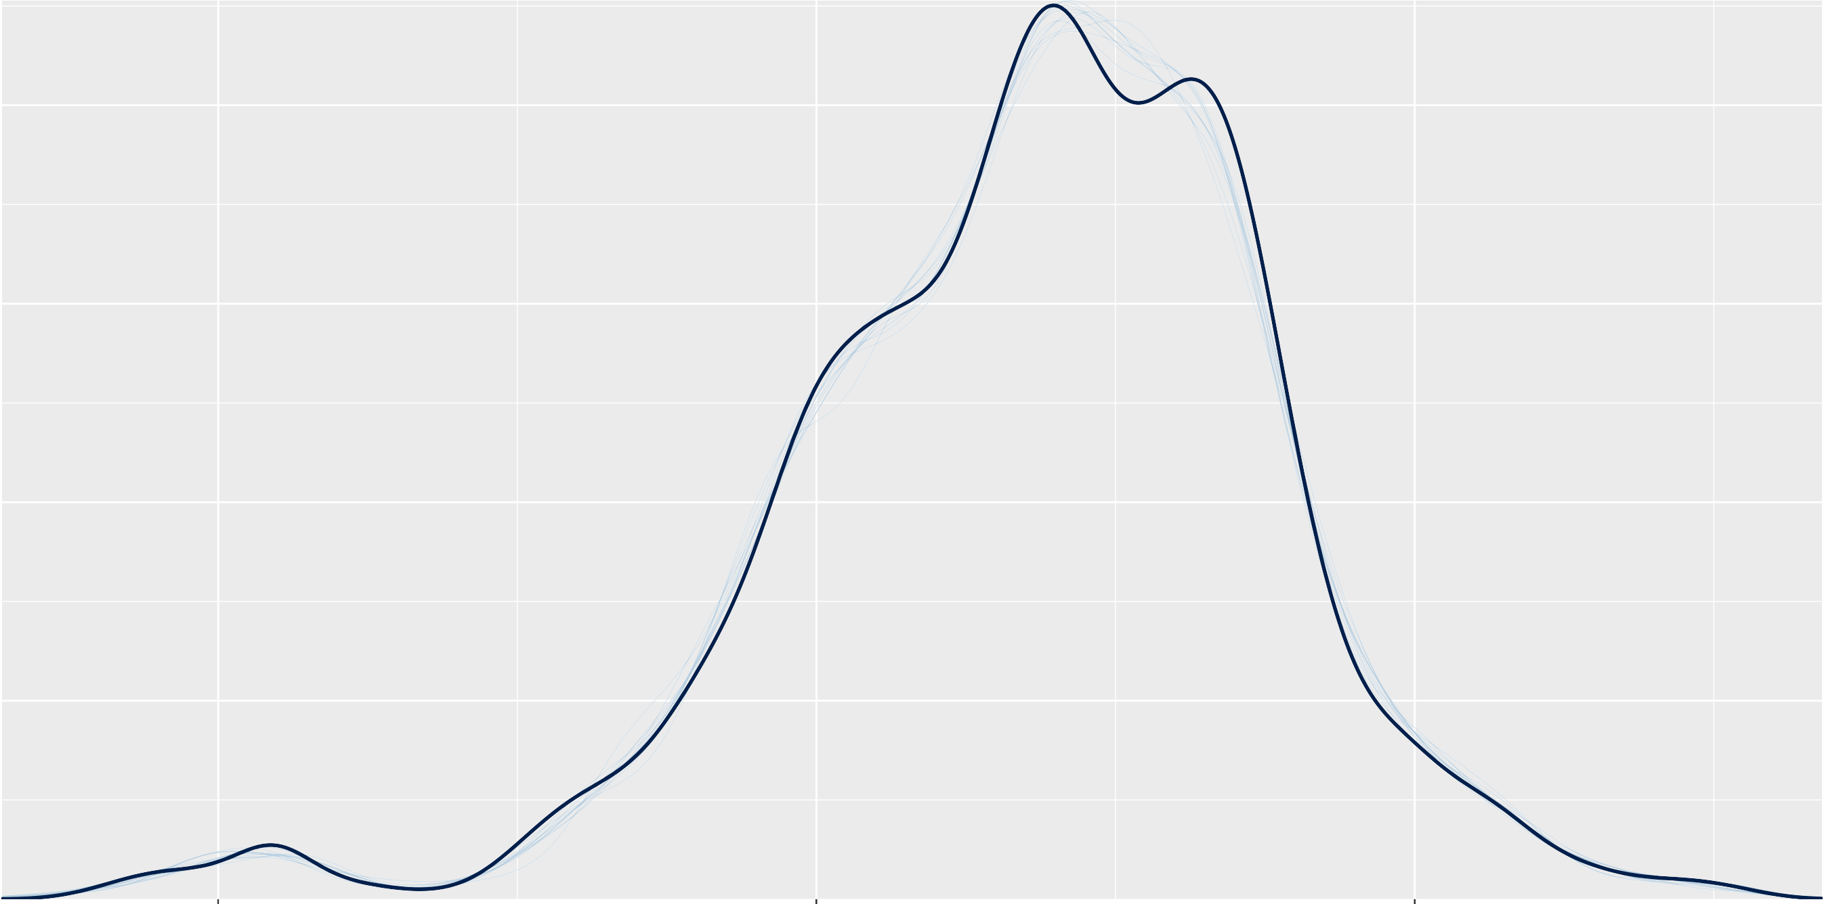5 10 15

*y*

*y*rep

12.9

12.6

12.3

1.15

1.10

b_Intercept

1.05

1.00

0.15

0.10

b_LogBiomassKGMean

sd_Larger Intercept

0.05

0.00

0 200 400 600 800 1000 0 200 400 600 800 1000 0 200 400 600 800 1000

sd_Larger:ReefCluster Intercept

Intercept

0.125

0.100

0.075

0.050

0.025

0.15

0.10

0.05

18.4

18.3

sigma

### Chain

1

2

3

4

0.000

0.00

18.2

0 200 400 600 800 1000 0 200 400 600 800 1000 0 200 400 600 800 1000

0.2 0.3

r_Larger[American.Samoa,Intercept]

r_Larger[Australia,Intercept]

0.1

0.2

0.0

−0.1

−0.2

0.1

0.0

−0.1

0 200 400 600 800 1000 0 200 400 600 800 1000

## **B** PP Check − site fec biomass se

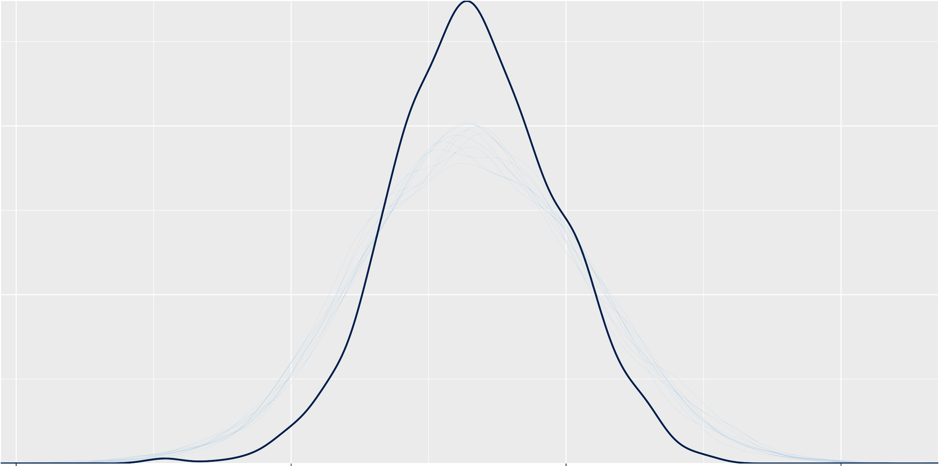10 15 20 25

*y*

*y*rep

6.0

5.5

0.6

−0.2

b_DepthCategory>10m

b_DepthCategory0M4m

5.0

0.4

−0.4

4.5

4.0

0.2

0.0

−0.6

0 200 400 600 800 1000 0 200 400 600 800 1000 0 200 400 600 800 1000

b_Intercept

0.4

b_CleanHabitatCrest

b_CleanHabitatFlat

b_CleanHabitatLagoon_Backreef

0.4

0.0

−0.4

0.00

−0.25

−0.50

−0.75

0.0

−0.4

### Chain

1

2

3

4

−0.8

0 200 400 600 800 1000 0 200 400 600 800 1000 0 200 400 600 800 1000

2.0

b_ProtectionRestricted

b_ProtectionUnfishedHigh

0.8

1.5

0.4

1.0

0.0

0.5

−0.4

# B

0.0

0 200 400 600 800 1000 0 200 400 600 800 1000

## PP Check − brms 20cmBiomass

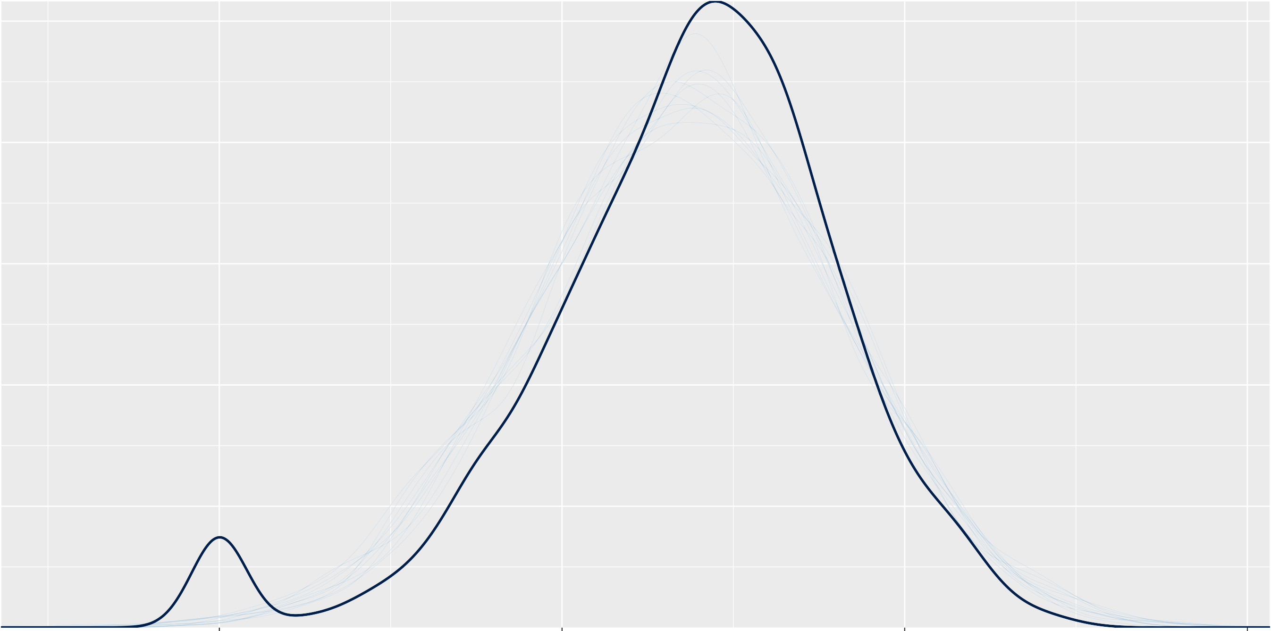*y*

*y*rep

18.5

0.50

0.0

−0.2

b_DepthCategory0M4m

18.0

0.25

−0.4

17.5

0.00

−0.6

0 200 400 600 800 1000 0 200 400 600 800 1000 0 200 400 600 800 1000

b_Intercept

b_DepthCategory>10m

b_CleanHabitatLagoon_Backreef

0.5

0.0

−0.5

−1.0

0.0

−0.4

b_CleanHabitatCrest

−0.8

−1.2

0.25

0.00

b_CleanHabitatFlat

−0.25

−0.50

### Chain

1

2

3

4

0 200 400 600 800 1000 0 200 400 600 800 1000 0 200 400 600 800 1000

0.75

0.50

1.5

1.0

b_ProtectionUnfishedHigh

0.25 0.5

b_ProtectionRestricted

0.00

0.0

0 200 400 600 800 1000 0 200 400 600 800 1000

## **B** PP Check − brms fecundity se

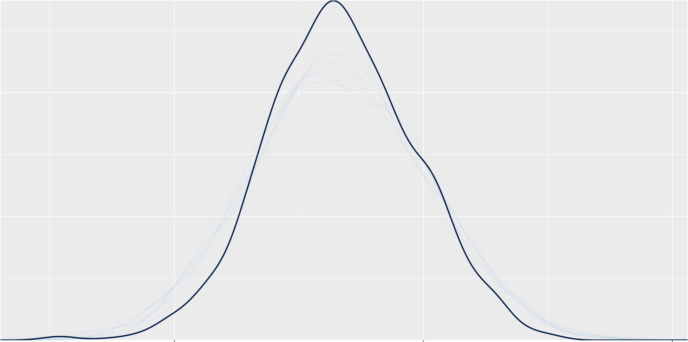*y*

*y*rep

−0.1

b_Intercept

b_DepthCategory>10m

b_DepthCategory0M4m

5.5

0.4

−0.2

5.0

0.2

−0.3

−0.4

4.5

0.0

−0.5

0 200 400 600 800 1000 0 200 400 600 800 1000 0 200 400 600 800 1000

b_CleanHabitatLagoon_Backreef

0.50

0.25

0.00

−0.25

−0.50

0.00

−0.25

b_CleanHabitatCrest

−0.50

−0.75

0.2

0.0

b_CleanHabitatFlat

−0.2

−0.4

−0.6

### Chain

1

2

3

4

0 200 400 600 800 1000 0 200 400 600 800 1000 0 200 400 600 800 1000

0.6

b_ProtectionRestricted

b_ProtectionUnfishedHigh

1.0

0.3

0.5

0.0

−0.3

# B

0.0

0 200 400 600 800 1000 0 200 400 600 800 1000

## PP Check − brms matf se

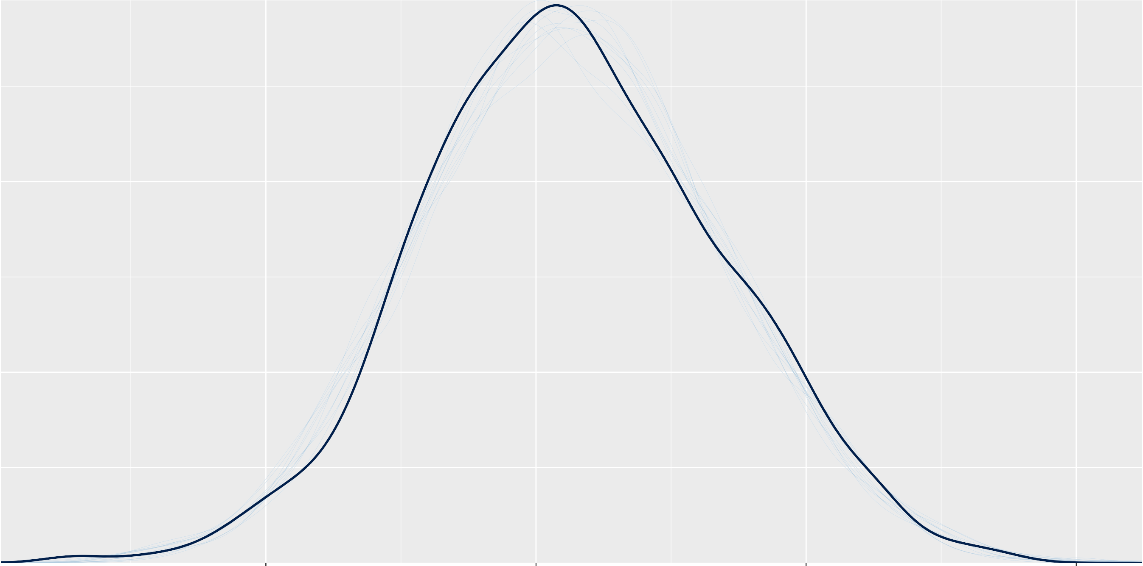*y*

*y*rep

0.6

b_Intercept

19

0.4

18

0.2

17

0.0

16

−0.2

15

−0.25

−0.50

b_DepthCategory>10m

b_DepthCategory0M4m

−0.75

−1.00

−1.25

0 200 400 600 800 1000 0 200 400 600 800 1000 0 200 400 600 800 1000

b_CleanHabitatFlat

b_CleanHabitatLagoon_Backreef

0.5

0.0

−0.5

−1.0

−1.5

1.0

0.5

b_CleanHabitatCrest

0.0

−0.5

0.5

0.0

−0.5

### Chain

1

2

3

4

0 200 400 600 800 1000 0 200 400 600 800 1000 0 200 400 600 800 1000

1.5 3

b_ProtectionRestricted

b_ProtectionUnfishedHigh

1.0 2

0.5 1

0 200 400 600 800 1000 0 200 400 600 800 1000

## **B** PP Check − SERRANIDAE brms fecundity hurdlelog

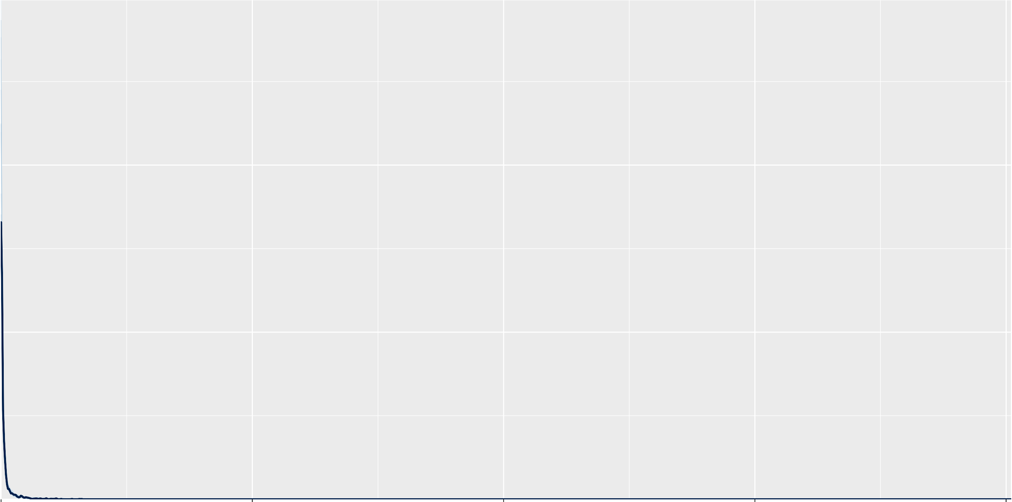*y*

*y*rep

1 1.0

b_Intercept

0.0

0 0.5

−0.4

−1 0.0

−0.8

0 200 400 600 800 1000 0 200 400 600 800 1000 0 200 400 600 800 1000

b_DepthCategory>10m

b_DepthCategory0M4m

b_CleanHabitatLagoon_Backreef

0.5

0.0

−0.5

−1.0

−1.5

−2.0

0.0

−0.5

b_CleanHabitatCrest

−1.0

−1.5

0.0

−0.5

b_CleanHabitatFlat

−1.0

−1.5

### Chain

1

2

3

4

0 200 400 600 800 1000 0 200 400 600 800 1000 0 200 400 600 800 1000

1.5 2

b_ProtectionRestricted

b_ProtectionUnfishedHigh

1.0 1

0.5

0.0

−0.5

# B

0

−1

−2

0 200 400 600 800 1000 0 200 400 600 800 1000

## PP Check − SERRANIDAE brms fecundity zeros hurdle

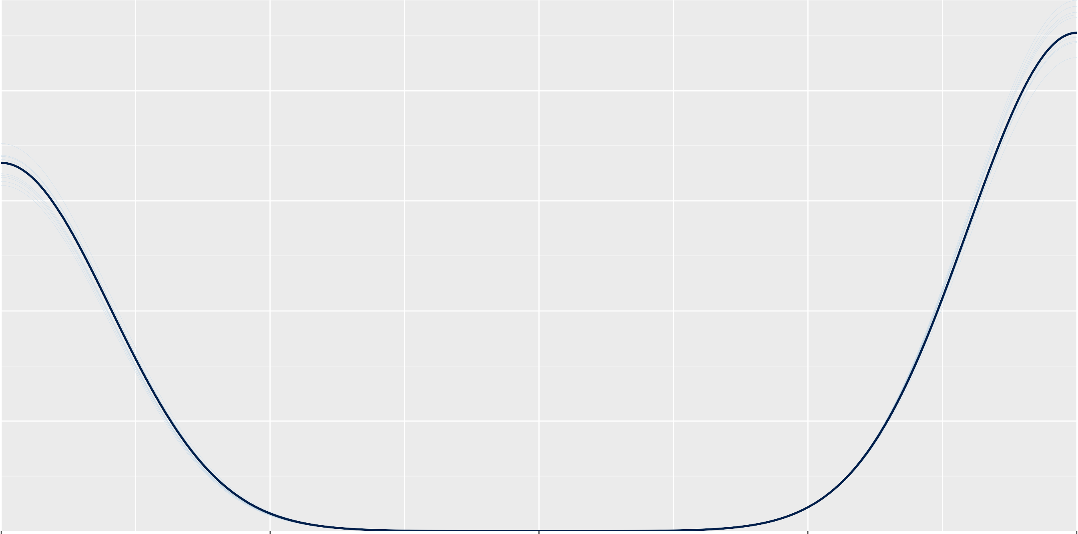*y*

*y*rep

18

b_Intercept

0.5

17

−0.25

−0.50

b_DepthCategory>10m

b_DepthCategory0M4m

16 0.0

−0.75

15

−0.5

−1.00

−1.25

0 200 400 600 800 1000 0 200 400 600 800 1000 0 200 400 600 800 1000

b_CleanHabitatFlat

b_CleanHabitatLagoon_Backreef

0.5

0.0

−0.5

−1.0

−1.5

1.0

0.5

b_CleanHabitatCrest

0.0

−0.5

−1.0

0.5

0.0

−0.5

### Chain

1

2

3

4

0 200 400 600 800 1000 0 200 400 600 800 1000 0 200 400 600 800 1000

3

b_ProtectionRestricted

b_ProtectionUnfishedHigh

1.5

2

1.0

1

0.5

0.0

# B

0

0 200 400 600 800 1000 0 200 400 600 800 1000

## PP Check − SERRANIDAE brms fecundity

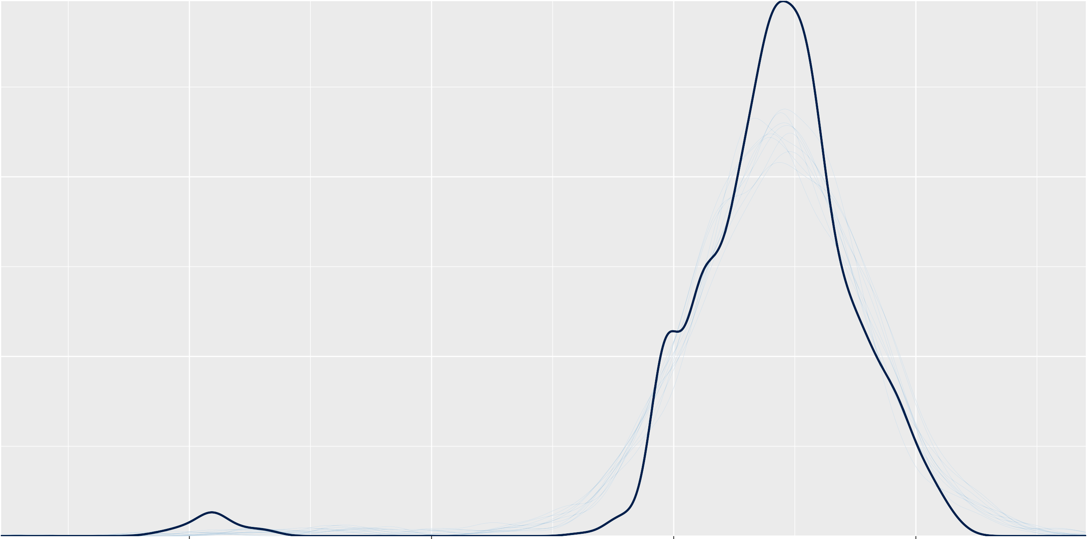*y*

*y*rep

0.4

b_Intercept

b_DepthCategory>10m

b_DepthCategory0M4m

18.5

0.2

0.0

18.0

0.0

−0.2

17.5

−0.2

−0.4

0 200 400 600 800 1000 0 200 400 600 800 1000 0 200 400 600 800 1000

0.6

0.4

0.2

0.0

−0.2

0.25

0.00

b_CleanHabitatCrest

−0.25

−0.50

0.25

0.00

b_CleanHabitatFlat

−0.25

−0.50

### Chain

1

2

3

4

−0.4

−0.75

0 200 400 600 800 1000 0 200 400 600 800 1000 0 200 400 600 800 1000

b_ProtectionUnfishedHigh

b_CleanHabitatLagoon_Backreef

0.6

1.0

0.3

b_ProtectionRestricted

0.5

0.0

−0.3

# B

0.0

0 200 400 600 800 1000 0 200 400 600 800 1000

## PP Check − SCARIDAE brms fecundity hurdlelog

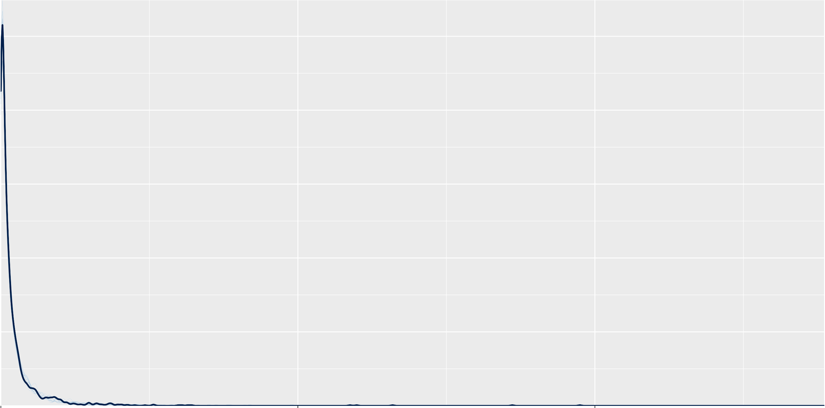e+00 5e+09 1e+10

*y*

*y*rep

17.6

17.2

0.50

0.25

0.00

0.25

0.00

b_DepthCategory>10m

b_DepthCategory0M4m

−0.25

16.8

−0.25

b_Intercept

−0.50

0 200 400 600 800 1000 0 200 400 600 800 1000 0 200 400 600 800 1000

1.0

b_CleanHabitatCrest

b_CleanHabitatFlat

b_CleanHabitatLagoon_Backreef

0.5

0.0

0.0

−0.5

0.0

−0.5

### Chain

1

2

3

4

−0.5

−1.0

0 200 400 600 800 1000 0 200 400 600 800 1000 0 200 400 600 800 1000

b_ProtectionUnfishedHigh

1.00

0.75

1.5

0.50

1.0

0.25

0.5

0.00

# B

0.0

0 200 400 600 800 1000 0 200 400 600 800 1000

b_ProtectionRestricted

## PP Check − SCARIDAE brms fecundity

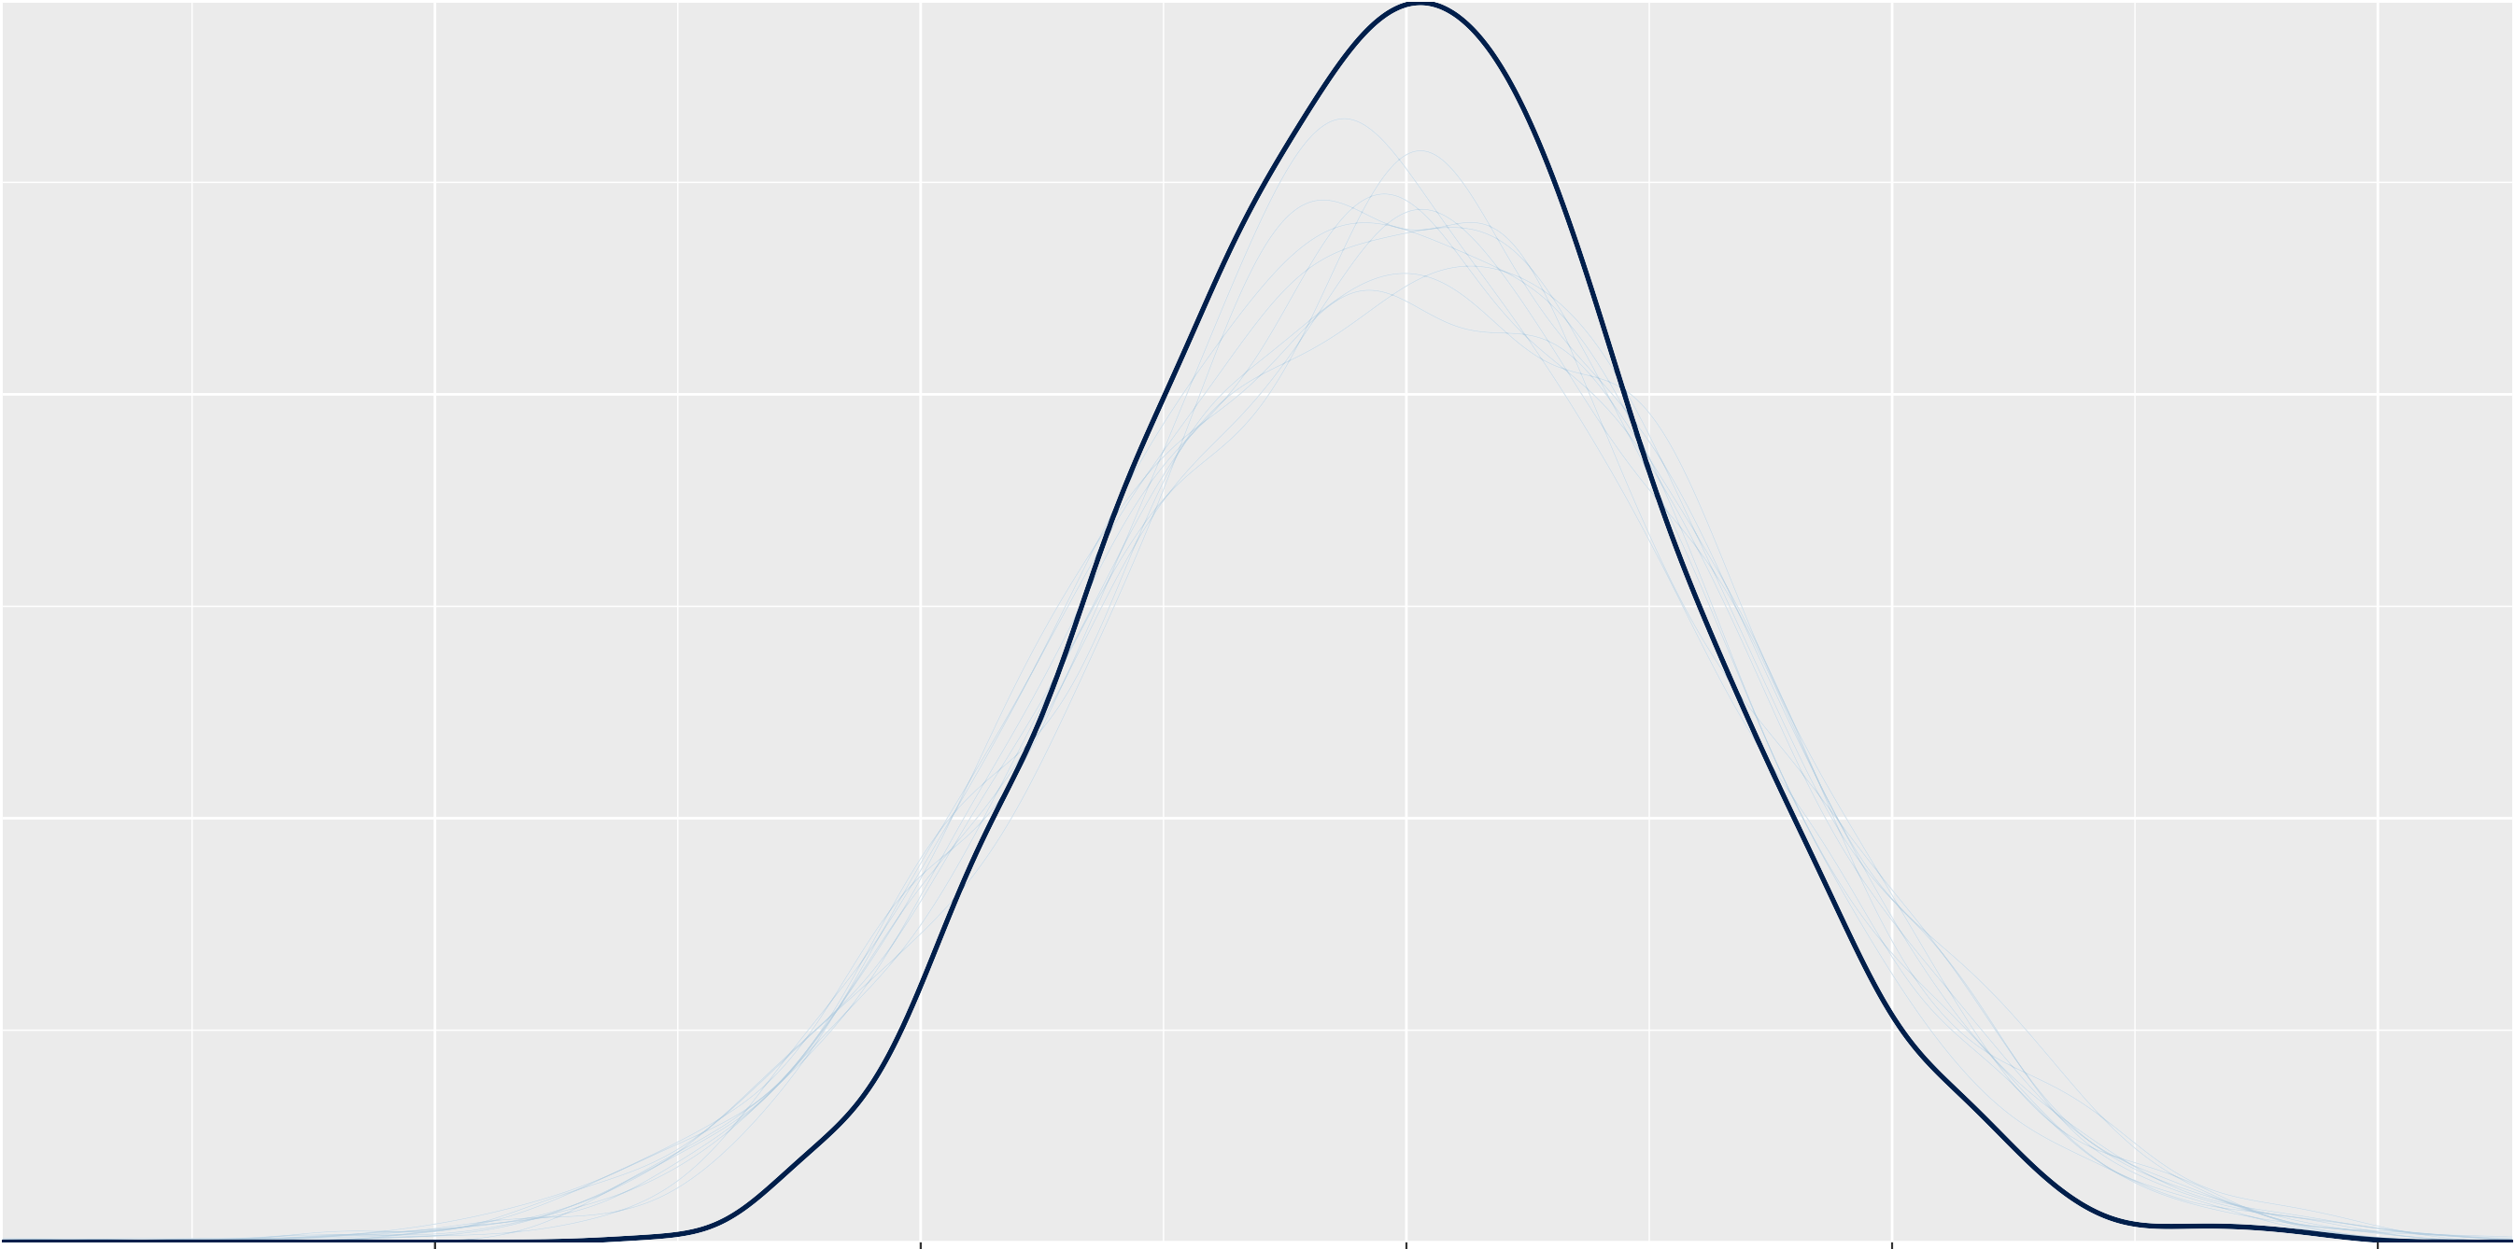12.5 15.0 17.5 20.0 22.5

*y*

*y*rep

17.6

17.2

16.8

16.4

0.50

0.25

0.00

−0.3

−0.6

b_DepthCategory>10m

b_DepthCategory0M4m

−0.9

−0.25

b_Intercept

0 200 400 600 800 1000 0 200 400 600 800 1000 0 200 400 600 800 1000

b_CleanHabitatCrest

b_CleanHabitatLagoon_Backreef

0.5

0.0

−0.5

−1.0

0.5

0.0

−0.5

−1.0

0.0

−0.5

b_CleanHabitatFlat

### Chain

1

2

3

4

0 200 400 600 800 1000 0 200 400 600 800 1000 0 200 400 600 800 1000

1.5

b_ProtectionRestricted

b_ProtectionUnfishedHigh

0.5

1.0

0.0

0.5

−0.5

# B

0.0

−0.5

0 200 400 600 800 1000 0 200 400 600 800 1000

## PP Check − LUTJANIDAE brms fecundity hurdlelog

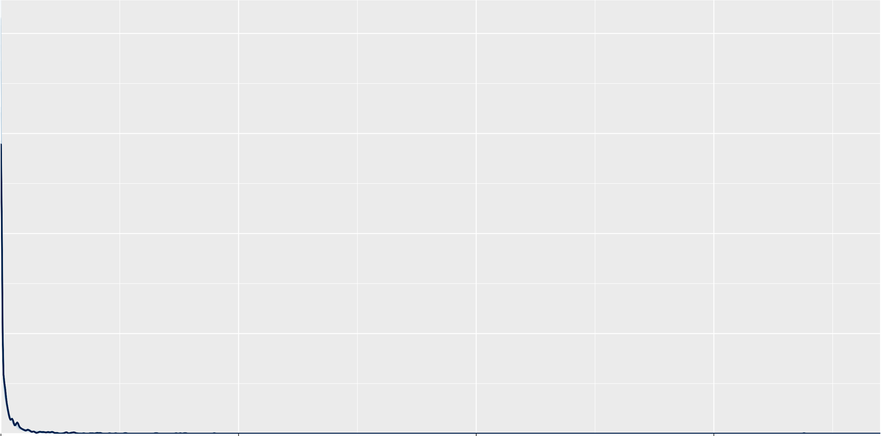*y*

*y*rep

16.5

0.0

16.0

0.5

−0.5

b_DepthCategory>10m

15.5

0.0

−1.0

15.0

−0.5

b_Intercept

b_DepthCategory0M4m

−1.5

0 200 400 600 800 1000 0 200 400 600 800 1000 0 200 400 600 800 1000

1

b_CleanHabitatCrest

b_CleanHabitatFlat

1 0.5

0 0 0.0

−1 −0.5

−1

### Chain

1

2

3

4

−2 −1.0

b_CleanHabitatLagoon_Backreef

0 200 400 600 800 1000 0 200 400 600 800 1000 0 200 400 600 800 1000

0.5

b_ProtectionRestricted

b_ProtectionUnfishedHigh

1

0.0

0

−0.5

−1.0

# B

−1

0 200 400 600 800 1000 0 200 400 600 800 1000

## PP Check − LUTJANIDAE brms fecundity

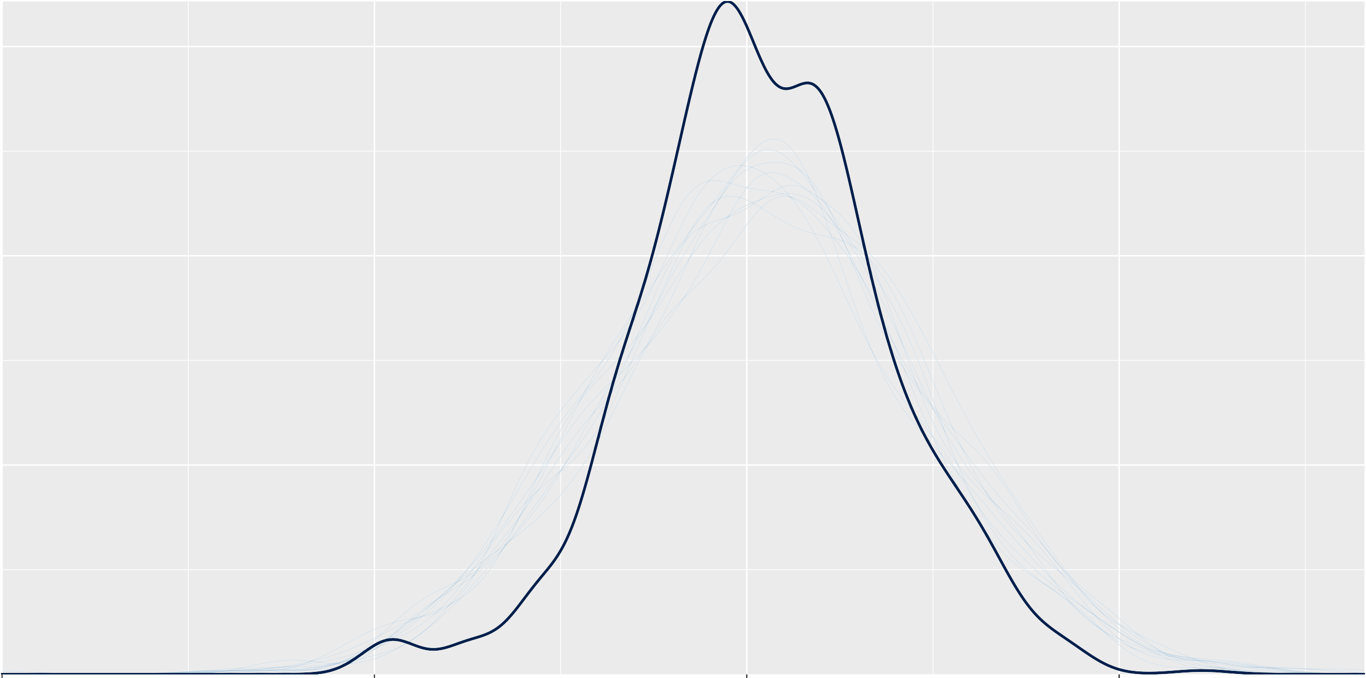*y*

*y*rep